Meals on Wheels Program
Institution
Course
Name

Meals on the wheels program involves picked ready to eat food from a designated place and then distributing it to the needy people within the community. The program traces its back to Great Britain during the Second World War. During this time, German planes bombed English soil leaving many people homeless, and others had no food to eat. Thus, many people during this time were vulnerable to starving. There was a group of women, The Women's Volunteer Service for Civil Defense, who responded to the emergence by preparing dishes and delivering them to their disadvantaged neighbors (Soifer & Pickering-Bernheim, 2014). They also carried with then refreshments which they supplied to the canteens which were served to the servicemen during World War II. It is these canteens that were referred to as "Meals on Wheels," and thus the first food program was born.
After the war, the United States of America started its own experimental meal program. In January 1954 the first American home delivered food program was started in Philadelphia. It was formed after the Philadelphia Health & Welfare Council kicked-off its own home-delivered meal program under the request of Margaret Toy who was a social worker (Soifer et al., 2014). The food program was formed in order to provide food to the homebound elders among others who were in need of food within the area who would otherwise have gone hungry.
The case was as it is today, many of the people who were involved in the program did not require hospitalization, but required a helping hand so that they could be able to be independent at some point in the future. Most of those people who volunteered to were high school students who were later on referred to as ‘Platter Angels.' They would prepare food, pack and then embark of the distribution process (Soifer et al., 2014). They would reach out to the houses of the elderly and the needy people within the community. They delivered two meals where one meal was supposed to be taken during lunch hour, and the remaining meal was to be taken during super time. Besides, they packed a cold sandwich and milk along with varying side dishes.
However, the people who were steering the program were supposed to identify the elderly people were indeed the services that they were providing. They also started charging around 40 and 80 cents per day in order to cater partly for the cost that they were incurring (Wacker & Roberto, 2008). Had there been no Lighthouse program, many of the elderly people would have been hospitalized in order to ensure that they received the nutrition that they required to regain and maintain their strength.
As stated above, the program was meant for only the people who were in need- the people who would otherwise go hungry if not provided. Thus, the people who were organizing and running the food program turned to hospital social services, the Philadelphia Department of Public Assistance, and the Visiting Nurse Society so that they could refer them to potential people for the program (Wacker et al., 2008).
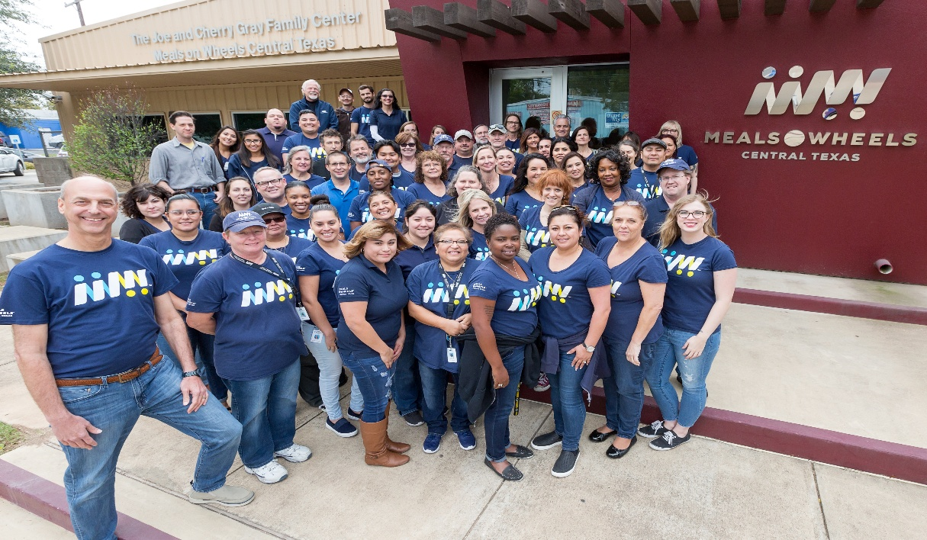
Link:https://www.google.com/url?sa=i&rct=j&q=&esrc=s&source=images&cd=&cad=rja&uact=8&ved=2ahUKEwjS-ve81IbiAhWNxoUKHbFIANAQjRx6BAgBEAU&url=https%3A%2F%2Fwww.mealsonwheelscentraltexas.org%2Fabout-us&psig=AOvVaw3aq-It0cJplJGuWa0cY-gs&ust=1557223639471066

References
Soifer, S., McNeely, J. B., Costa, C., & Pickering-Bernheim, N. (2014). Community economic development in social work. New York: Columbia University Press.
Wacker, R. R., & Roberto, K. A. (2008). Community resources for older adults: Programs and services in an era of change. Los Angeles, Calif. [u.a.: Sage.

